Mental Disorder

Suresh kumar Mandala
Department of computer science and Artificial intelligence,
SR university, warangal-506371 Telangana,
mandala.suresh83@gmail.com

Potharaboina Dhanraj Yadav

Department of computer science and Artificial intelligence

SR University, Warangal-506731 Telangana,

dhanrajyadavpotharaboina@gmail.com

Swathi Balija
Department of Computer Science and Artificial Intelligence,
SR University, Warangal-506371 Telangana,
jrswathi.hi@gmail.com

Manchikatla Sai Charan

Department of computer science and Artificial intelligence

SR University, Warangal-506731 Telangana,

Saicharan63363@gmail.com

Reddy Srivallika
Department of computer science and Artificial intelligence
SR University, Warangal-506731 Telangana,
reddysrivalili414@gmail.com

Mallela Rohith

Department of computer science and Artificial intelligence

SR University, Warangal-506731 Telangana,

rohithmallela2005@gmail.com

This study examines the causes, symptoms, and therapies of mental illnesses, with a focus on the interactions between psychological, environmental, and hereditary components. It discusses the efficacy of pharmacological and psychological therapies, evaluates contemporary diagnostic techniques, and emphasizes the significance of individualized treatment regimens in enhancing patient results. A wide range of illnesses affecting behavior, emotion, and cognition are together referred to as mental disorders. These problems can cause severe suffering and make it difficult to go about daily tasks. Among these illnesses, depression is one of the most common and crippling conditions, marked by enduring melancholy, hopelessness, and loss of interest in or enjoyment from activities. Excessive concern, fear, or apprehension are the hallmarks of anxiety disorders, which include panic disorder, social anxiety disorder, and generalized anxiety disorder. These symptoms are frequently accompanied by bodily manifestations like perspiration and a fast heartbeat.

Disturbances in thought, perception, emotions, and behavior are hallmarks of schizophrenia, a chronic and complicated mental illness that impairs social and professional functioning. Bipolar disorder presents difficulties with mood management and stability because of its episodes of extreme mood swings, which can range from manic highs to depressed lows. The symptoms of attention-deficit/hyperactivity disorder (ADHD) include impulsivity, hyperactivity, and inattention. These disorders affect social, occupational, and academic performance.
Keywords: hereditary variables, environmental influences, diagnosis, treatment, genesis of mental disorders.
I.INTRODUCTION
A broad spectrum of psychological problems that profoundly affect a person's thoughts, feelings, behavior, and day-to-day functioning are referred to as mental disorders. These illnesses, which include bipolar disorder, schizophrenia, anxiety, and depression, are caused by intricate interplay between biological, psychological, environmental, and hereditary factors. Mental diseases are highly prevalent and have a significant impact on society globally. They affect millions of people regardless of age, gender, or socioeconomic background and are a major source of social and economic hardship. Reducing the overall health disparities linked to mental health concerns and enhancing quality of life depend heavily on diagnosing, treating, and managing these conditions. Keys to rehabilitation include identifying the symptoms and getting professional assistance as soon as possible.

Mental diseases, sometimes referred to as psychiatric disorders or mental illnesses, are illnesses that impact a person's perception, thinking, feeling, behavior, or mood. These conditions can seriously hinder a person's capacity to carry out daily tasks and may be distressing for the person as well as for their friends, family, and the larger community. A vast array of illnesses are included in the category of mental disorders, each having distinct symptoms, causes, and available treatments.

II.LITERATURE SURVEY
GEL. and others The difficulties and variations in psychiatric classification schemes are covered in the paper.It notes that Germany does not have an official classification system and that the Deutscher Verein für Psychiatrie recommends using a diagnostic method. Also included are historical viewpoints on psychiatric classification that highlight the contributions of influential individuals including Falret, Baillarger, and Kraepelin.
Steven E. Hyyman The study examines the shortcomings of the DSM-IV diagnostic criteria as well as the difficulties in coming up with accurate disease classifications. It draws attention to the DSM-III diagnostic criteria's polythetic nature, which permits many criterion combinations for the same diagnosis and affects study interpretations.It draws attention to the DSM-III diagnostic criteria's polythetic aspect, which influences how research is interpreted by permitting many combinations of criteria for the same diagnosis. The authors stress that in order to provide more accurate classifications, considerable modifications to diagnostic criteria are required to keep up with advances in neuroscience and genetics. There is also discussion of historical viewpoints on the creation of diagnostic criteria, including the Feighner criteria and research diagnostic criteria. The research urges a shift towards more informative alterations for future classifications, arguing that adding new illnesses or just improving existing ones won't produce meaningful diagnoses.

Canon, Tyrone D. et al. Humans' prefrontal cortex facilitates higher-order cognitive functions including reasoning and working memory. Deficits in working memory are associated with a genetic diathesis of schizophrenia. The severity of spatial working-memory problems varies according to the number of relatives with schizophrenia. Quantitative trait loci (QTLs) for complex psychiatric characteristics such as schizophrenia are the subject of genetic studies. When analyzing psychiatric diseases genetically, endophenotypes are essential. Single-gene illnesses are distinguished from typical mental disorders by theoretical frameworks. Endophenotypes have been shown to be useful in genetic investigations of schizophrenia in recent publications.

Larry Gamm and associates In rural locations, mental health problems are common, particularly among adult males and children. These problems include high suicide rates. State and local authorities in rural health have recognized mental disorders as a major health concern and a major source of concern in rural communities. Effectively addressing these difficulties is hampered by the dearth of mental health specialists in rural locations, such as psychiatrists and child psychiatrists. People under the age of eighteen who suffer from serious emotional disturbance (SED) find that it greatly affects how they go about their everyday lives in rural areas.The study emphasizes the need for improved mental health services in rural areas while highlighting the epidemiological features of psychiatric diseases in America.

Marie-Katherine Risley et al.Girls have higher rates of mood and anxiety disorders, whereas males have higher rates of behavioral disorders. Approximately one-fourth of youngsters suffer a mental problem within the preceding year, with anxiety disorders being the most common condition in children.Recent epidemiologic surveys seek to determine distinct risk profiles that account for variations in the prevalence of mental and behavioral disorders among kids according to ethnicity.Compared to past surveys, more children with mental problems are receiving services from physicians, schools, or mental health professionals. It is still uncommon for young people from ethnic minorities to receive mental health care. ICD-10-CM codes for various degrees of hallucinogen use disorders, including phencyclidine use disorder, are provided in the paper. Coding notes for major or mild frontotemporal neurocognitive disorders are included, along with instructions on which codes to use in which situations. There are specifiers for mild, moderate, and severe instances in early and prolonged remission in the codes for phencyclidine-using disorders. Coding guidelines specific to frontotemporal illnesses and neurocognitive problems resulting from frontotemporal lobar degeneration are provided. The significance of precisely classifying behavioral abnormalities in neurocognitive diseases is emphasized in the paper.

T. Bedirhan Ustun When evaluating the public health significance of mental diseases, Disability Adjusted Life Years (DALYs) rank highly. The study highlights the need of bridging the knowledge gap between successful mental health treatments and scientific evidence. The notion of mental diseases as brain disorders is supported by modern brain imaging. Mental health disease management techniques should be created with long-term, recurrent conditions in mind. The significance of accurately diagnosing and treating severe mental diseases is covered in the study. In the field of mental health treatment, quality control and adherence to scientific guidelines are essential. The report contains projections and estimates about mental illnesses.

Stephen and others Stigma around mental illness reduces possibilities in life and impairs one's ability to operate independently. According to research, the American public's lack of understanding regarding mental illness following World War II contributed to attitudes that were derogatory and social distancing. Social stigma sometimes prevents people with mental illnesses from getting treatment, despite the fact that they affect individuals, families, and entire civilizations. Major mental diseases are rooted in genetic predispositions, however stigma difficulties may not be entirely addressed by medical models. Even with greater awareness, stigma seems to be growing, particularly for severe mental illnesses, perhaps as a result of media and technology developments.

The David Goldberg group explains the types, traits, and causes of common behavioral and emotional illnesses that affect people of all ages. gives a concise summary of current developments in our knowledge of the causes and development of disorders such as anxiety, depression, antisocial conduct, and drug abuse. highlights the roles of genes and circumstances in the development of various illnesses while discussing the epidemiology of these disorders throughout childhood, adolescence, and adulthood. suggests that the best approach to identifying susceptibilities to psychopathology is to use a developmental model.

Written by Ian Goodyer, Foundation Professor of Child and Adolescent Psychiatry at the University of Cambridge, and David Goldberg, Professor Emeritus at the Institute of Psychiatry, King's College London

Dr. F.H. Kooy This research examines the connection between maniacal-depressive psychosis and glycosuria caused by diuretine, a derivative of caffeine. Individuals with depressive emotions, especially those exhibiting significant anxiety and agitation, may experience glycosuria. The study investigates how glycosuria directly affects physiological responses, particularly in melancholy. It has been discovered that patients with anxiety and agitation—not just melancholia, but also neurasthenia and psychasthenia—showed the greatest rise in blood sugar levels. The study explores the metabolic effects of glycosuria in a range of mental health disorders.
.

Suvisaari and associates The study examined the mental health of young individuals between the ages of 19 and 34, emphasizing treatment contacts, sociodemographic correlations, and prevalence of both lifetime and current mental disorders. Based on predetermined criteria, a variety of screening instruments, including the GHQ-12, K10, SCOFF, CIDI section G, MDQ, CAGE, and others, were utilized to choose participants for mental health interviews. To appropriately determine prevalences, statistical analysis took into account cluster sampling design, non-response adjustments, expansion weights, post-stratification weights, and multiple imputation. Along with questions on many aspects of mental health and substance use, the MEAF questionnaire includes screens such as K10, GHQ-12, SCOFF, Munich-Composite International Diagnostic Interview, Mood Disorder Questionnaire, and CAGE.

Alonso and associates In six European nations, the ESEMeD study examined prevalence estimates of alcohol, anxiety, and mood disorders. The goal of the project was to enhance community mental health diagnosis and treatment. Due to varying diagnostic tools and selection processes, previous research had comparability issues. To improve cross-national comparability, the ESEMeD project examined mental diseases based on the DSM-IV and ICD-10 using the WMH-CIDI. Researchers from a variety of universities in several nations participated in the study.

Amstrong Levi The diagnosis, treatment, and legal, ethical, and cultural aspects of mental illness are the main topics of this study. It must be at least five pages long in APA format and address particular facets of a selected DSM-5 diagnosis. Historical influences, diagnostic standards, prevalence figures, suggested courses of action, ethical considerations, cultural difficulties, and suggestions for further study are some of the criteria. Students are required to adhere to stringent formatting and content rules and submit a rough draft of three pages. Tests, participation in class, and the final research paper—which accounts for 15% of the total grade—are the three main grading criteria.

Kevin c. Ronald et al. The study examines the descriptive epidemiology of DSM-IV mental disorders that are prevalent in the US. With high comorbidity, the majority of individuals with a history of mental illness experienced first onsets in childhood or adolescence. More research is required to determine the effects of early diagnosis and treatment of child and adolescent illnesses on public health. Numerous grants and organizations, including NIMH, NIDA, SAMHSA, RWJF, and WHO, provided funding for the study. The epidemiology of mental problems in children is little understood, and further information on prevalence, correlates, and changes across childhood and adolescence is required.

Trautmann Sebastian et al. The economic burden of mental illnesses on society is much greater than that of chronic physical illnesses like diabetes and cancer. By examining trade-offs between risks and money, the value of statistical life (VSL) technique is used to estimate the economic burden of mental diseases. Despite comparable economic costs and levels of disability, stigmatization and misinformation play a role in the underfunding of mental health treatment when compared to somatic diseases. A variety of methods are used to present the economic costs of mental illnesses, such as direct and indirect expenses, the effect on economic growth, and the statistical life value.

Ulrich Hanschen and colleagues In primary care, anxiety disorders receive little investigation while accounting for a sizable fraction of the population. It is difficult for primary care doctors to diagnose mental problems; only half of people with threshold disorders get diagnosed. The diagnostic classification of mental diseases can be complicated because of changing paradigms and overlapping symptoms. Rather than being particular to mental diseases, general factors also affect poor diagnostic identification in basic care. General practitioners play a major role in the treatment and referral of mental health illnesses, however their efficacy is still restricted.
III.PROPOSED APPROACH
- Overview:
A general grasp of the wide spectrum of illnesses that impact the mind and behavior is provided by an overview of mental disorders. Psychiatric disorders, sometimes known as mental illnesses or disorders of the mind, are broad categories of problems marked by abnormalities in perception, behavior, emotions, thoughts, and feelings. A person's ability to operate on a daily basis, their quality of life, and their general well-being can all be greatly impacted by these disorders. Here are some essential elements to take into account when reviewing mental illnesses.
- Feature Extraction:
It is necessary to recognize and classify a variety of facets of an individual's thoughts, feelings, behaviors, and physiological reactions in order to extract features from mental diseases. This is a broad method of feature extraction for mental health conditions:
a. Features bases on Author’s behaviour:
1.Diagnostic Criteria: Start with the diagnostic criteria found in commonly used categorization systems, such as the International categorization of Diseases (ICD-10) or the Diagnostic and Statistical Manual of Mental Disorders (DSM-5). Observable behaviors, subjective sensations, and duration/severity thresholds are common examples of these criteria.

2.Symptoms: List the precise symptoms that are connected to the illness. There are several areas into which symptoms can be subdivided, including mood, cognition, perception, and behavior. Depression, for instance, can cause feelings of worthlessness, hunger or sleep patterns abnormalities, persistent unhappiness, and loss of interest in activities.
3.Severity:Determine how serious each symptom is. Rating scales, self-report questionnaires, or clinical judgment may be used in this. The severity may vary over time and range from minor to severe. Start Time and Length: Date of onset and duration of symptoms should be noted. Certain illnesses have requirements about the age at which symptoms must appear or the length of time that they must last.
4.Triggers and Context: Think about the circumstances surrounding the occurrence of symptoms as well as the things that cause or worsen them. Stressful life experiences, outside circumstances, interpersonal connections, and cultural influences could all be examples of this.
5.Functional Impairment: Assess how symptoms affect day-to-day functioning, such as relationships, self-care, employment, and education. A crucial criterion for many mental disorders is functional impairment, which aids in differentiating between clinical situations and typical fluctuations in behavior or mood.
.
b. Features based on reader’s behaviour:
6.Cognitive Patterns: Determine the cognitive patterns that are linked to the disorder, such as skewed thinking, illogical ideas, or cognitive biases. People who suffer from anxiety disorders, for instance, could overestimate the threat or catastrophize.
7.Emotional Regulation: Examine emotional regulation issues, such as the strength, duration, and suitability of emotional reactions. Emotional numbness, emotional lability, or trouble recognizing and expressing feelings could be involved.
8.Psychosocial Factors: Examine psychological aspects such family relationships, past trauma, socioeconomic level, and cultural background. These elements may have an impact on how mental illnesses manifest, develop, and progress.
.
9.Comorbidity: Recognize the possibility of comorbid problems since many people with mental illnesses have symptoms that fall into more than one diagnostic category. Comorbidity might make it more difficult to diagnose and prepare for therapy.
10.Bodily Symptoms: Somatic complaints or bodily symptoms are another way that some mental illnesses can present. Changes in appetite, sleep issues, exhaustion, gastrointestinal issues, or psychosomatic symptoms are a few examples.
11.Neurobiological Markers: Examine any possible neurobiological indicators linked to the illness, such as structural or functional anomalies in the brain, imbalances in neurotransmitters, or inherited tendencies. Neuroimaging, genetic testing, and other biological indicators might offer important insights into the underlying causes of mental diseases, even though they are not usually evaluated in ordinary clinical practice.
Through a methodical extraction of these characteristics, medical professionals can gain a thorough comprehension of each patient's presentation and customize treatment plans to meet their specific requirements. Furthermore, feature extraction methods can be used by researchers to improve our knowledge of the causes, progression, and management of mental illnesses.

IV. EXPERIMENTAL RESULTS
ALGORITHMS USED IN THIS PREDICTION:
1.LOGISTIC REGRESSION
2.RANDOM FOREST
3.SVM (SUPPORT VECTOR MACHINE)
4.GRADINET BOOSTING
5.XG BOOST
6.CAT BOOST

1.LOGISTIC REGRESSION:
For classification problems where the objective is to predict the likelihood that an instance belongs to a specific class or not, one supervised machine learning approach that is utilized is called logistic regression. An algorithm based on statistics examines the connection between two data elements.
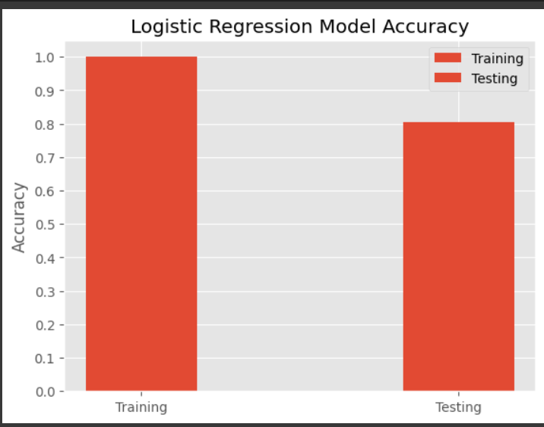


2.RANDOM FOREST:
A random forest generates a large number of decision trees. A random subset of the characteristics and data are used by each tree. Combining the forecasts from each tree results in the final forecast. High precision and avoidance of overfitting result from this.

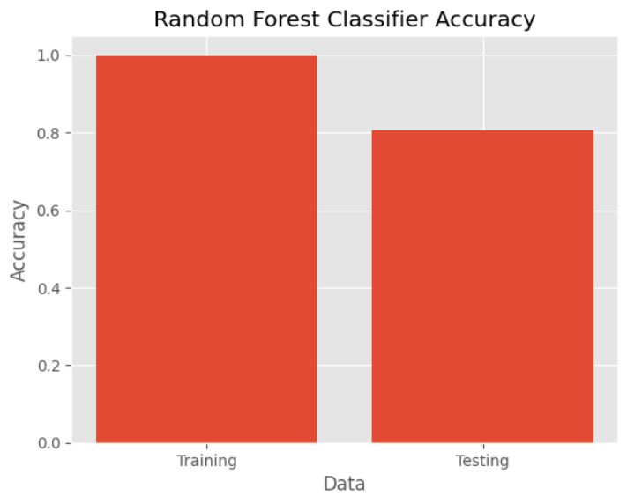
3.SVM (SUPPORT VECTOR MACHINE):
Supervised learning (SVM) is a powerful method that is applied to classification tasks. With support vector machines (SVM), the goal is to determine the appropriate hyperplane to divide classes by mapping data points into a higher-dimensional space. SVM efficiently finds patterns in patient data for HF prediction, dividing patients into HF-positive and HF-negative groups according to feature vectors taken from their medical records.
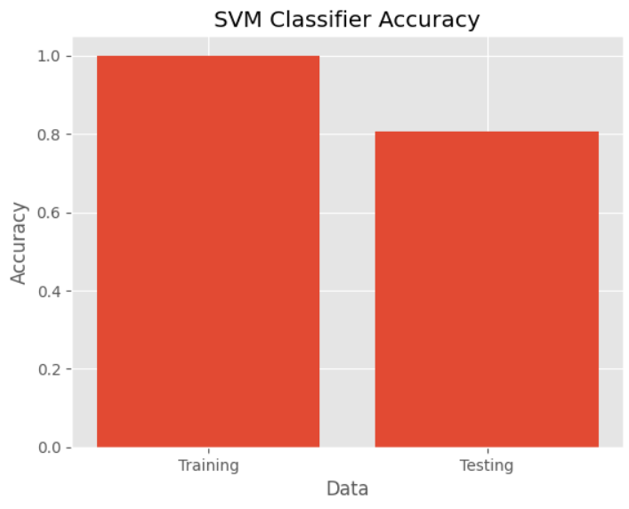


4.GRADINET BOOSTING:
A machine learning algorithm called gradient boosting is applied to both regression and classification problems. In order to create a strong prediction model, it builds an ensemble of weak prediction models, usually decision trees. Gradient Boosting is implemented in Python using the Gradient Boosting Classifier and Gradient Boosting Regressor classes provided by the sklearn module.
.
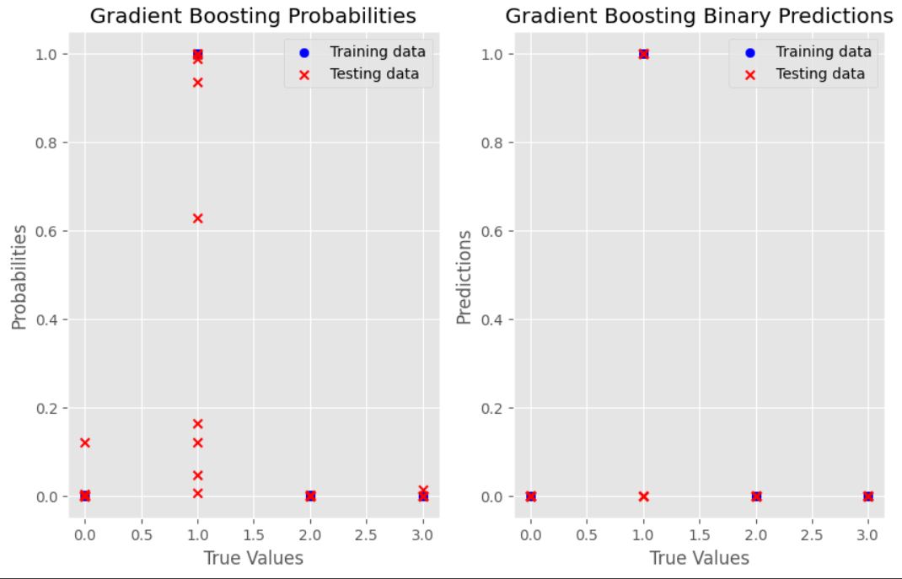


5.XG BOOST:
A scalable and effective distributed gradient boosting library for machine learning model training is called XGBoost. It is an ensemble approach that generates a stronger prediction by aggregating the predictions of several weak models.

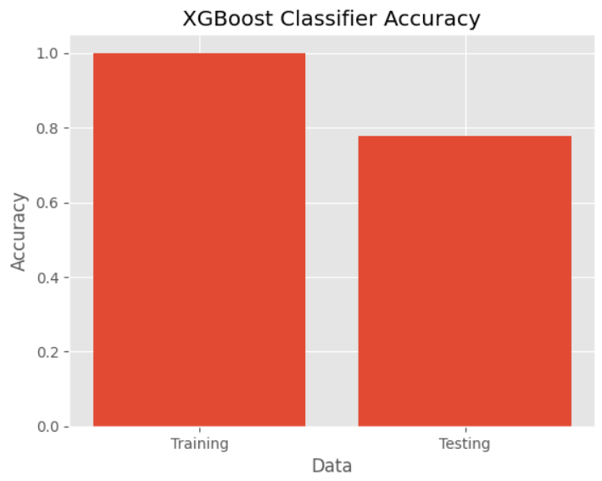



6.CAT BOOST:
Yandex created the CatBoost gradient boosting algorithm, which is renowned for its effectiveness, performance, interpretability, simplicity, and versatility. It frequently performs faster and more accurately than other gradient boosting methods, and it can handle both numerical and categorical information without the need for preprocessing.

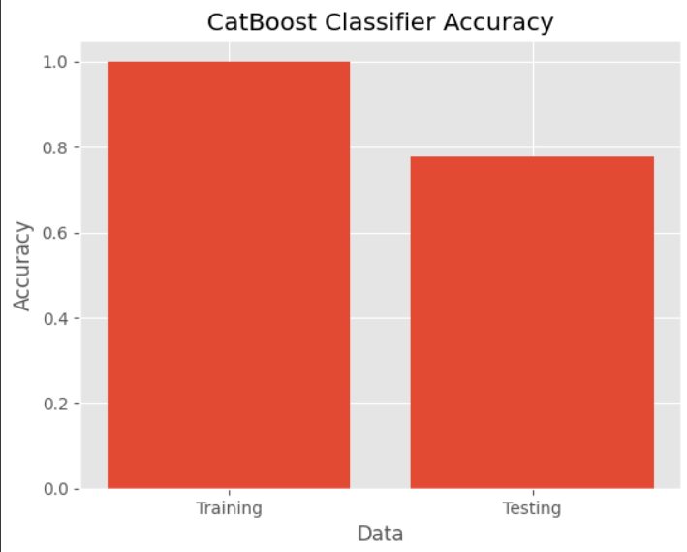


TEST ACCURACY OF DIFFERENT MODELS:
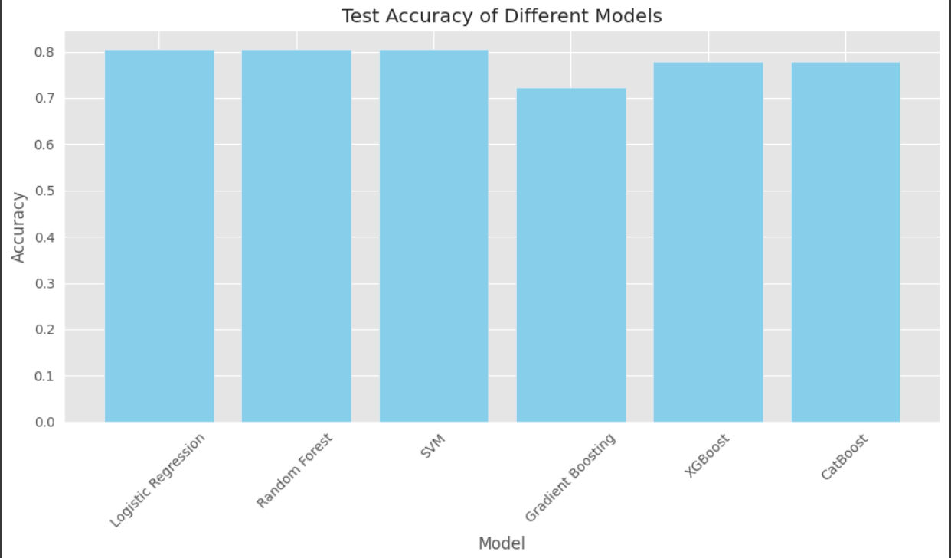

CLASSIFICATION REPORT:
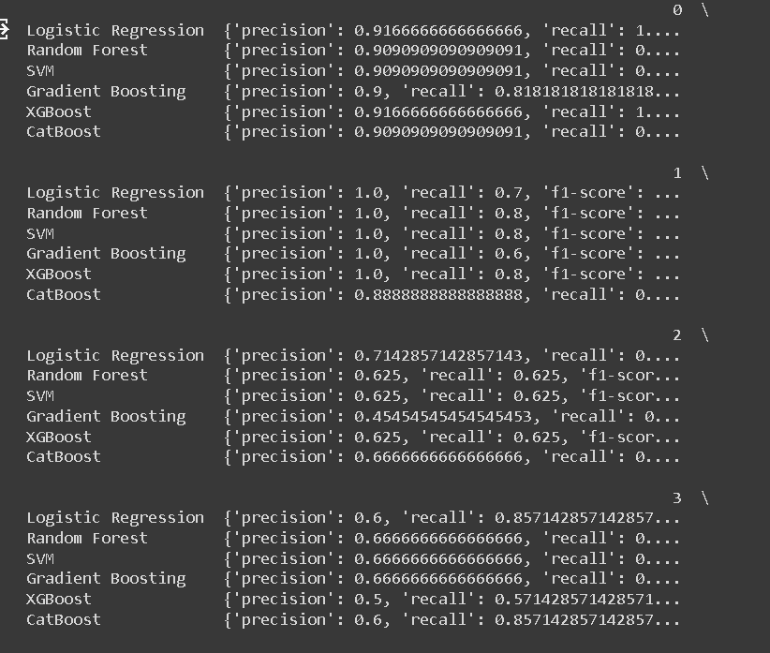

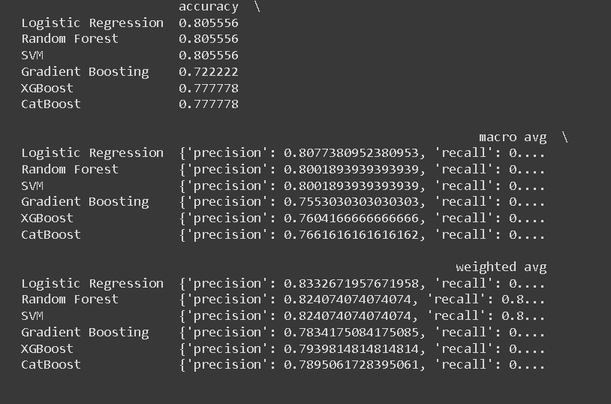

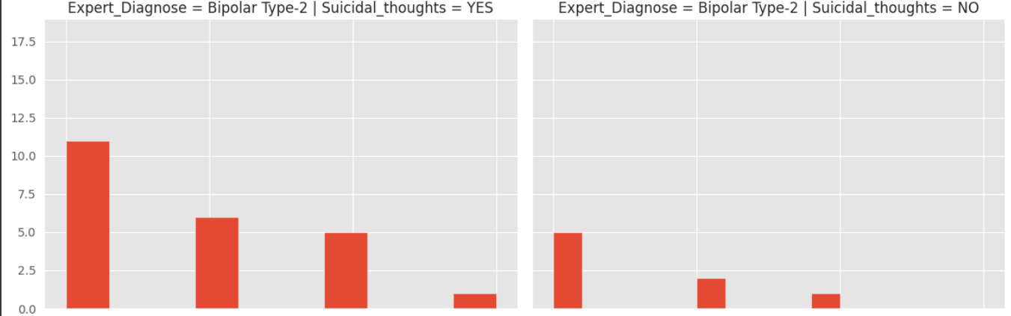

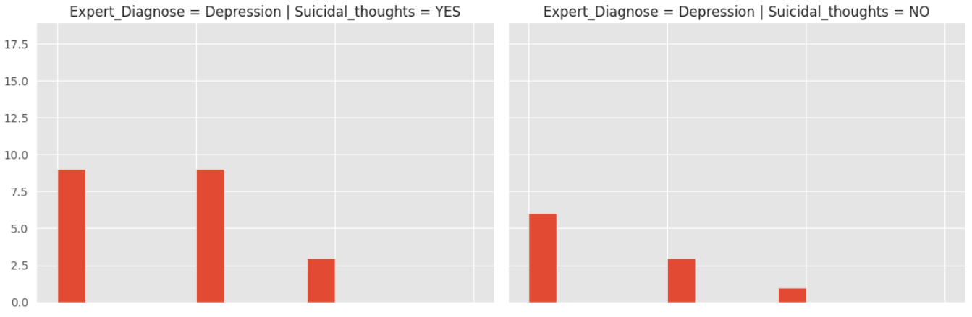
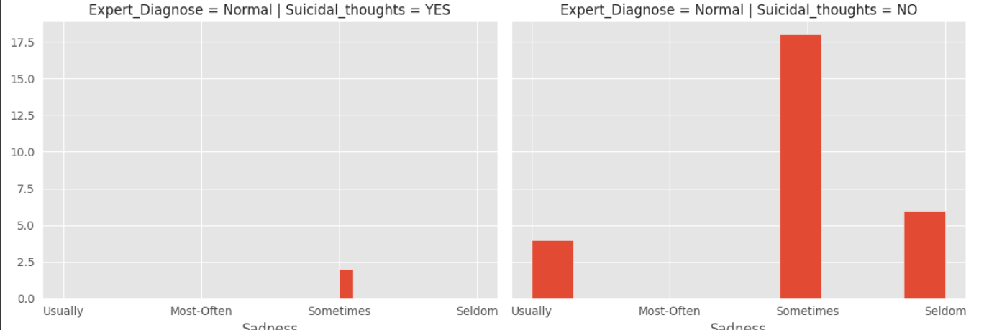
GITHUB LINK:

CONCLUSION:
In summary, mental diseases are intricate conditions that are impacted by a wide range of variables, such as psychological, environmental, and genetic components. The management of mental diseases has benefited greatly from the use of conventional diagnostic methods and therapeutic strategies like medication and psychotherapy. But it's imperative that we go beyond a one-size-fits-all strategy for mental health therapy and create individualized treatment programs that cater to the particular requirements of every patient.
Within the realm of mental health, machine learning—a subset of artificial intelligence—has shown great promise. Through the examination of extensive patient data sets, machine learning algorithms are able to spot trends and revelations that human physicians might miss. Machine learning can assist in identifying those who are at risk of acquiring mental health issues in the context of mental disorder prediction, allowing for early intervention and prevention.
For patients with mental health issues, machine learning can also be utilized to create individualized therapy programs. Machine learning algorithms can determine the best treatment strategies for each patient by evaluating their individual needs and circumstances through the analysis of patient data. This can lower the chance of side effects, enhance patient outcomes, and save healthcare expenses.
But there are certain difficulties and restrictions with using machine learning in mental health. It is imperative to tackle concerns pertaining to data privacy, bias, and interpretability to guarantee the ethical and efficient application of machine learning in the field of mental health. Ensuring the confidentiality of patient data and the impartiality and transparency of algorithms are critical. Furthermore, it's critical to make sure that practitioners and patients can both analyze and comprehend machine learning models.
In conclusion, by enabling individualized and focused treatment regimens, machine learning has the potential to completely transform the field of mental health. We can use machine learning to improve patient outcomes and lessen the stigma associated with mental health issues by tackling its obstacles and limits. To fully understand the potential of machine learning in mental health and to create morally and practically sound applications, more study is required. It's likely that developments in machine learning and other artificial intelligence technologies will influence mental health care in the future. We must not just address the ethical and societal ramifications of these technologies' use, but also keep investigating their possibilities.

REFRENCES:
- KAGGLE: https://www.kaggle.com/datasets/cid007/mental-disorder-classification
- Machine Learning in Mental Health: A Review of Opportunities and Challenges
- Machine Learning for Predicting Mental Health Outcomes: A Systematic Review
- Machine Learning in Psychiatry: A Review
- Machine Learning for Mental Health: A Review of Methods, Applications, and Challenges
- Machine Learning for Predicting Mental Health Disorders: A Review
- Machine Learning in Mental Health: A Review of Opportunities and Challenges
- Machine Learning for Predicting Mental Health Outcomes: A Systematic Review
- Machine Learning in Psychiatry: A Review
- Machine Learning for Mental Health: A Review of Methods, Applications, and Challenges
- Machine Learning for Predicting Mental Health Disorders: A Review
- Machine Learning in Mental Health: A Review of Opportunities and Challenges
- Machine Learning for Predicting Mental Health Outcomes: A Systematic Review
- Machine Learning in Psychiatry: A Review
- Machine Learning for Mental Health: A Review of Methods, Applications, and Challenges
- Machine Learning for Predicting Mental Health Disorders: A Review
- Machine Learning in Mental Health: A Review of Opportunities and Challenges
- Machine Learning for Predicting Mental Health Outcomes: A Systematic Review
- Machine Learning in Psychiatry: A Review
- Machine Learning for Predicting Mental Health Disorders: A Review

